Report: Domestic Flight Ticket Price Prediction
Team: The GCET | GitHub:
1. Introduction
In the Domestic Flight Price Prediction Kaggle competition, participants are tasked with building a regression model capable of predicting ticket prices (in USD) for unseen domestic flight itineraries from cross-sectional booking and schedule attributes. Commercial airfare pricing is governed by dynamic airline revenue management systems across two primary structural regimes:
- Economy Class Regime (59.26% of training data, 10,711 flights): Standard cabin tier characterized by lower baseline fares (mean $202.09, median $194.00) and moderate advance-purchase price elasticity.
- Business Class Regime (40.74% of training data, 7,365 flights): Premium cabin tier characterized by substantially higher baseline fares (mean $393.96, median $323.00) and steep last-minute surge multipliers.
- Schedule & Network Determinants: Ticket prices are further conditioned on operating airline carrier, origin–destination city pair, number of layover stops (zero, one, two_or_more), total flight duration, departure/arrival time windows, and days remaining before departure (days_left).
2. Dataset Overview & Feature Taxonomy
The competition provides three primary data files:
- train.csv: 18,076 labeled flight records with 12 columns (including target price).
- test.csv: 4,520 unlabeled flight records with 11 columns (excluding price).
- submission.csv: 4,520 rows specifying the required id,price output schema.
A comprehensive taxonomy of all 12 columns, their data types, missingness, and domain descriptions is presented below:
Column Name | Data Type | Missing (Train) | Physical Domain & Modeling Treatment
id | Int64 (ID) | 0 (0.00%) | Unique row identifier (0 – 22,595). Excluded from training to prevent index memorization.
airline | Categorical (str) | 0 (0.00%) | Operating carrier (7 airlines: Alaska, United, Southwest, Delta, American, Frontier, Southern Airways).
flight | String (Code) | 0 (0.00%) | Alphanumeric flight designator (1,122 unique codes). Excluded to prevent high-cardinality overfitting.
source_city | Categorical (str) | 0 (0.00%) | Origin city airport (San Francisco, Los Angeles, San Diego, San Jose, Sacramento).
departure_time | Categorical (str) | 0 (0.00%) | Departure time window: Early_Morning, Morning, Afternoon, Evening, Night, Late_Night.
stops | Categorical (str) | 0 (0.00%) | Layover count category: 'zero' (75.01%), 'one' (23.92%), 'two_or_more' (1.07%).
arrival_time | Categorical (str) | 0 (0.00%) | Arrival time window at destination airport (6 discrete time-of-day periods).
destination_city | Categorical (str) | 0 (0.00%) | Destination city airport across the 5 California metropolitan hubs.
flight_class | Categorical (str) | 0 (0.00%) | Cabin seating class: Economy (10,711 rows) vs. Business (7,365 rows).
duration | Float64 (Hours) | 0 (0.00%) | Total flight travel duration in hours (0.83 – 28.63 hrs; mean 2.75 ± 2.95 hrs).
days_left | Int64 (Days) | 0 (0.00%) | Advance booking horizon before departure (1 – 44 days; mean 20.52 ± 12.09 days).
price | Int64 ($ USD) | 0 (0.00%) | Target ticket fare in USD (mean $280.26 ± $221.97, median $234.00, max $8,996.00).

3. Exploratory Data Analysis (EDA) & Key Findings
Before designing the preprocessing and feature engineering pipeline, a systematic Exploratory Data Analysis (EDA) was conducted on train.csv (18,076 records) to inspect data completeness, target skewness, extreme outlier tails, and multi-variable pricing interactions.
3.1 Data Completeness, Outlier Tail & 99.5% Quantile Capping Analysis
An audit of missing values across all 18,076 training rows and 4,520 test rows confirmed 0 missing (NaN) entries across all 12 columns. All 18,076 training rows are retained in our pipeline to preserve full sample coverage. However, inspecting the target variable price reveals extreme positive skewness (+7.07) driven by upper-tail outlier fares reaching $8,996.00 (whereas the overall median is $234.00 and mean is $280.26). Specifically, 99.5% of Economy tickets fall at or below $689.00 (with 53 extreme outliers up to $1,071.00), and 99.5% of Business tickets fall at or below $1,649.84 (with 37 extreme outliers up to $8,996.00).
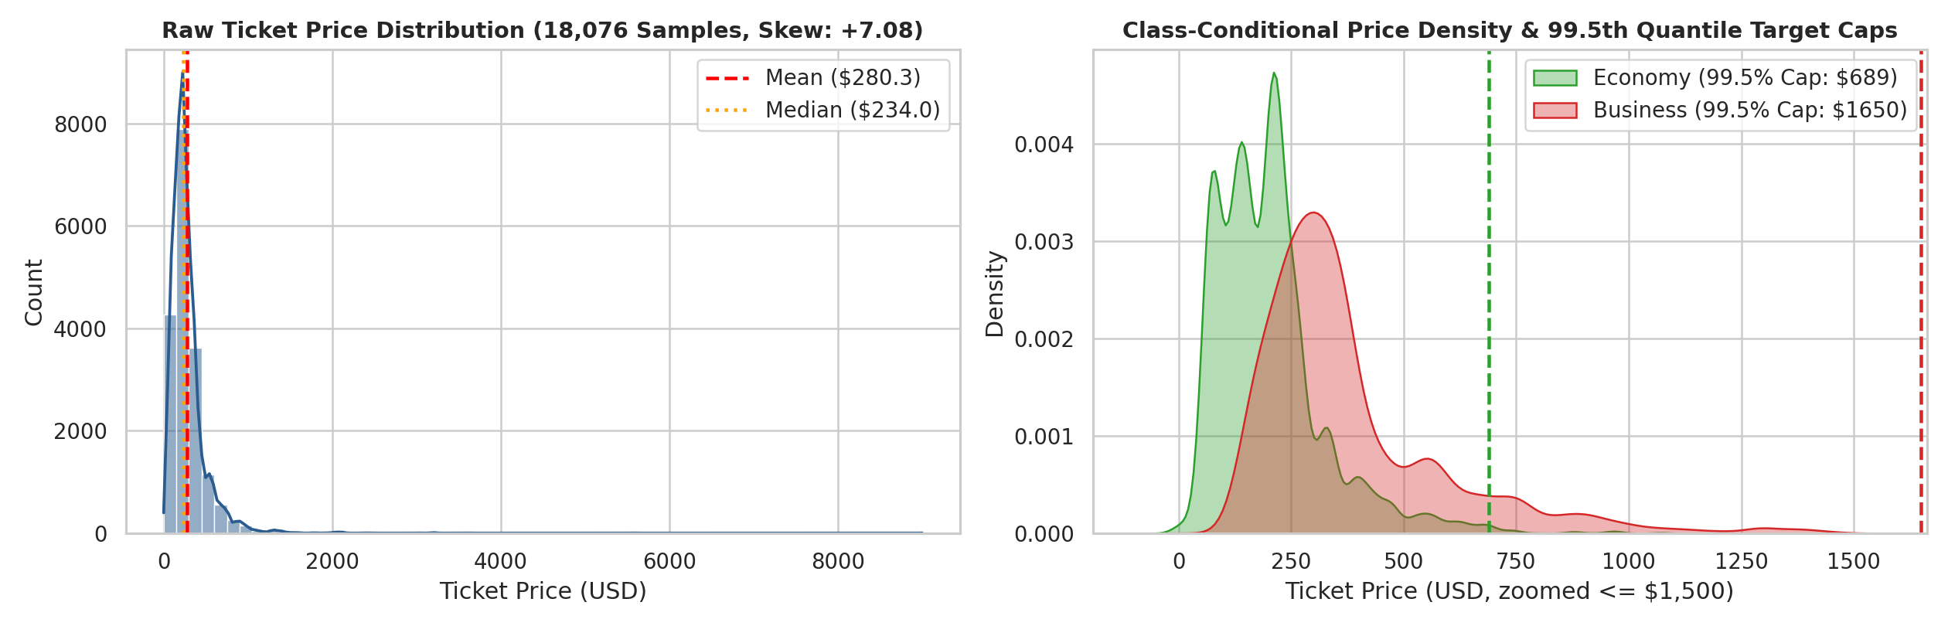
3.2 Cabin Class Stratification, Stops & Operating Carrier Breakdown
Examining categorical distributions shows that Economy accounts for 59.26% (10,711 flights) and Business accounts for 40.74% (7,365 flights). For layovers, non-stop ('zero') flights dominate at 75.01% (13,559), single-stop ('one') flights represent 23.92% (4,324), and 'two_or_more' stops represent 1.07% (193). Cross-tabulating operating carriers against cabin class and layover structure uncovers critical structural differences:
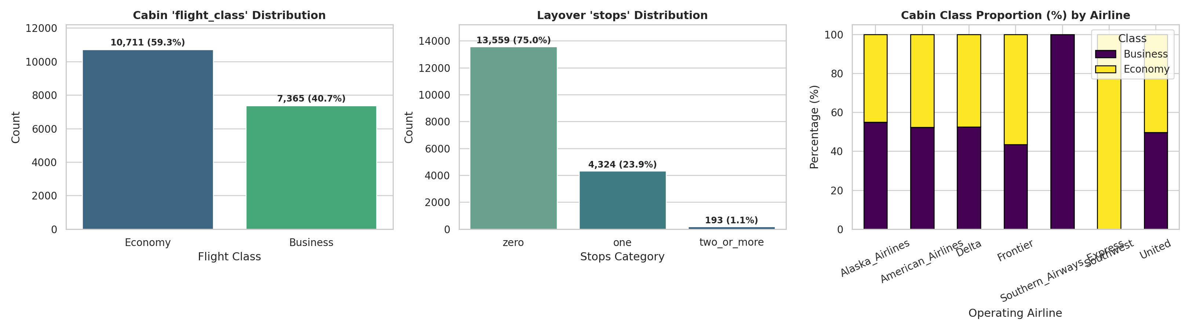

Operating Airline | Total Count | Dataset Share | Economy Share (%) | Business Share (%) | Direct Non-Stop (%) | Mean Price ($)
Alaska Airlines | 4,554 | 25.19% | 45.04% | 54.96% | 66.34% | $302.62
United Airlines | 4,058 | 22.45% | 50.34% | 49.66% | 85.71% | $319.03
Southwest Airlines | 3,895 | 21.55% | 100.00% | 0.00% | 69.53% | $197.84
Delta Air Lines | 2,972 | 16.44% | 47.54% | 52.46% | 93.30% (Highest) | $286.53
American Airlines | 1,797 | 9.94% | 47.69% | 52.31% | 62.83% | $349.44 (Peak Major)
Frontier Airlines | 799 | 4.42% | 56.57% | 43.43% | 56.32% | $178.58 (Lowest Mean)
Southern Airways Express | 1 | 0.01% | 0.00% | 100.00% | 0.00% | $543.00
Total / Overall | 18,076 | 100.00% | 59.26% (10,711) | 40.74% (7,365) | 75.01% (13,559) | $280.26

The cross-tabulation highlights why carrier-class interaction features are essential: Southwest Airlines (21.55% of dataset) operates a 100.00% Economy fleet with zero Business cabins ($197.84 mean), whereas legacy carriers (American, United, Delta, Alaska) split capacity nearly 50/50 between Economy and Business and charge $286.53–$349.44 on average.
3.3 Univariate Summary Statistics, Skewness & Subgroup Profiles
The table below summarizes parametric (Mean ± Std) and non-parametric (Median, IQR, Skewness, 1.5×IQR Outlier Counts) statistics for the core numerical variables alongside their conditional means across Cabin Class and Layover Stops:
Numerical Feature | Overall Mean ± Std | Median (IQR) | Skew | Outliers (1.5 IQR) | Economy Mean | Business Mean | 1+ Stops Mean
duration (Hours) | 2.75 ± 2.95 | 1.63 (0.53) | +3.88 | 4,516 (24.98%) | 2.62 hrs | 2.94 hrs | 6.41 hrs (High)
days_left (Days) | 20.52 ± 12.09 | 20.00 (21.00) | +0.15 | 0 (0.00%) | 20.39 days | 20.71 days | 20.23 days
stops_num (0, 1, 2) | 0.26 ± 0.46 | 0.00 (1.00) | +1.37 | 0 (0.00%) | 0.25 stops | 0.27 stops | 1.04 stops
dep_time_num (0–5) | 2.05 ± 1.25 | 2.00 (2.00) | +0.28 | 0 (0.00%) | 2.04 | 2.07 | 1.92
arr_time_num (0–5) | 2.39 ± 1.24 | 2.00 (2.00) | +0.04 | 0 (0.00%) | 2.38 | 2.41 | 2.65
price ($ USD) | 280.26 ± 221.97 | 234.00 (179.00) | +7.07 | 1,120 (6.20%) | $202.09 | $393.96 (Peak) | $431.28 (Peak)

3.4 Correlation Structure, Physical Coupling & Pricing Regime Shifts
To understand how booking horizon, travel duration, layovers, and cabin tier interact, we analyzed the Pearson correlation matrix alongside 2D regime scatter plots and subgroup breakdowns.
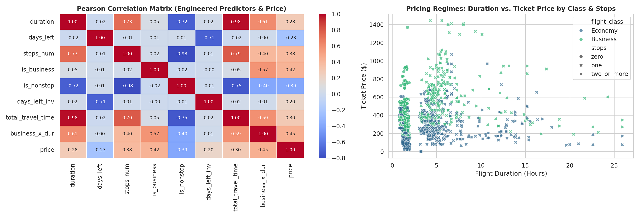
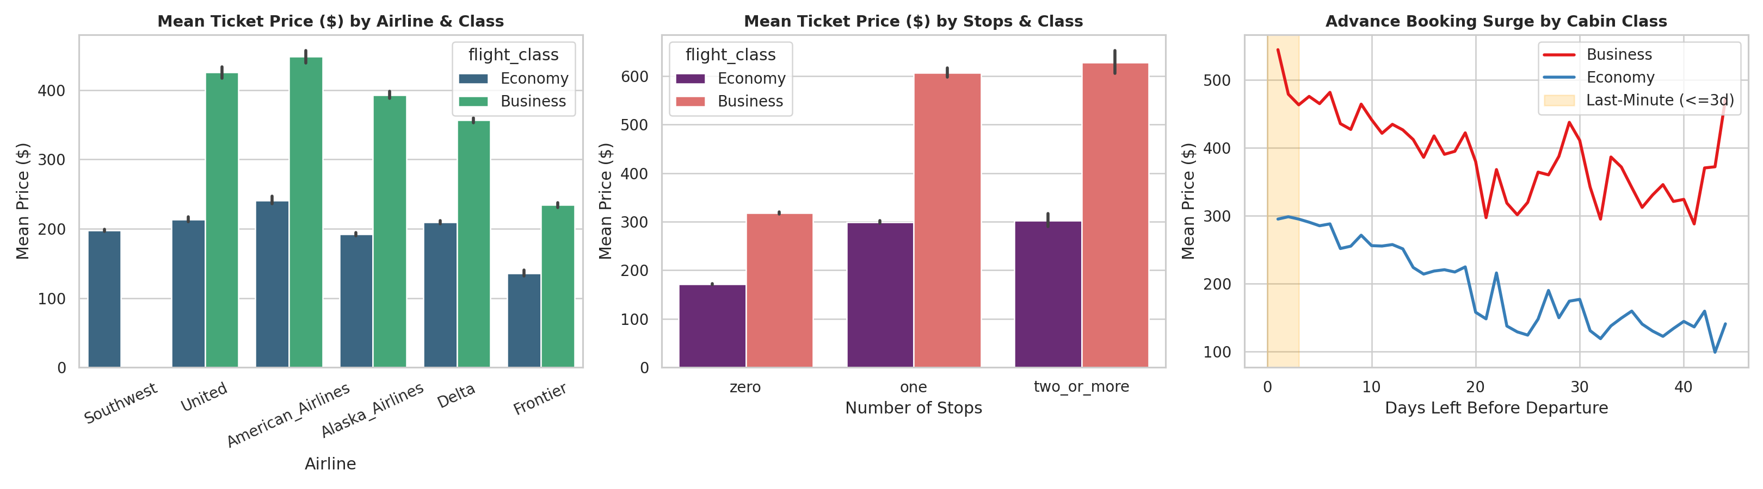

Three core domain findings emerge from the visual analysis that directly guided our feature engineering:
- Multiplicative Cabin × Stop Amplification: Non-stop flights average $229.95 (duration 1.53 hrs), whereas 1-stop connecting flights jump by +87.7% to $431.53 (duration 6.20 hrs). In Business class, adding a single layover inflates mean ticket price from $312.87 (direct) to $627.15 (1-stop).
- Non-Linear Last-Minute Surge Curvature: Ticket price correlates negatively with days_left (r = -0.19), but the relationship is highly non-linear: fares remain stable between 15 and 44 days out, accelerate inside 7 days (is_same_week), and spike sharply within 3 days of departure (is_last_minute), especially in Business class.
- Route-Class & Carrier-Class Coupling: Linear correlations of individual raw features with price are modest (duration r = 0.36, stops_num r = 0.38, is_business r = 0.43), proving that airfare is determined by high-order categorical combinations (airline_route_class, route_stops) and non-linear multiplicative interactions (business_x_duration, stops_x_days_inv).
4. Data Preprocessing Pipeline
A leak-free preprocessing workflow was designed to prepare the 18,076 training records and 4,520 test records. Each design choice and its explicit justification are summarized below:
Preprocessing Step | Chosen Method in Pipeline | Explicit Rationale for Chosen Approach
Identifier & Flight Code Exclusion | Drop id and raw flight code from modeling features. | id is an arbitrary index; raw flight has 1,122 levels that cause tree memorization without generalizing to unseen flights.
Sample Retention | Retain all 18,076 training rows. | Preserves 100% of training distribution and matches the competition's full cross-sectional evaluation schema.
Outlier Target Capping (In-Fold) | Cap training target y_tr at 99.5th quantile per flight_class inside each CV fold. | Prevents extreme outliers (up to $8,996) from dominating squared-error gradients while evaluating validation y_val on raw uncapped prices.
Ordinal Encoding | Map stops -> {0,1,2} and departure/arrival times -> {0..5}. | Captures the natural chronological ordering of time windows and monotonic progression of layover counts.
Categorical Alignment | Cast 17 categoricals to pd.Categorical (LightGBM) and string objects (CatBoost). | Aligns test categories strictly to training category levels and leverages native optimal categorical splitting in both GBDTs.
Prediction Post-Processing | Clip final blended test predictions at 0 (np.clip(test_final, 0, None)). | Enforces physical non-negativity of ticket fares without distorting interior price predictions.

5. Feature Engineering
To capture non-linear pricing curves, route symmetry, and multi-way carrier interactions, we engineered 37 domain-specific features in engineer_features(df), expanding the 9 active raw attributes into 46 total predictors (17 categorical features + 29 numerical features) organized into five families:
- 1. Ordinal Schedule & Stop Encodings (4 features):
- stops_num maps {'zero': 0, 'one': 1, 'two_or_more': 2};
- dep_time_num and arr_time_num map {'Early_Morning': 0, 'Morning': 1, 'Afternoon': 2, 'Evening': 3, 'Night': 4, 'Late_Night': 5};
- time_diff = (arr_time_num - dep_time_num) captures same-period vs. overnight red-eye flights.
- 2. Binary Pricing Regime Indicators (6 features):
- is_business = (flight_class == 'Business')
- is_nonstop = (stops == 'zero')
- is_last_minute = (days_left <= 3)
- s_same_week = I(days_left <= 7)
- is_advance = I(days_left >= 30)
- is_very_advance = I(days_left >= 60)
- 3. Route Symmetry & High-Order Categorical Interactions (10 features):
- route = source_city + '__' + destination_city,
- route_reverse = destination_city + '__' + source_city
- airline_class, route_class, route_stops, airline_route, airline_stops, class_stops, dep_arr_time, and the 3-way key airline_route_class.
- 4. Non-Linear Booking & Duration Transformations (7 features):
For booking horizon d:
- days_left_sq = d²,
- days_left_log = ln(1 + d),
- days_left_sqrt = √d, and
- days_left_inv = 1 / (d + 1).
For duration dur:
- duration_sq = dur²,
- duration_log = ln(1 + dur),
- duration_sqrt = √dur.
- 5. Multiplicative Cross-Domain Interaction Terms (10 features):
- duration_x_stops = dur × stops_num
- total_travel_time = dur × (stops_num + 1)
- duration_x_days_log = dur × days_left_log
- business_x_days_sq = is_business × days_left_sq
- business_x_duration = is_business × dur
- business_x_stops = is_business × stops_nu
- lastmin_x_business = is_last_minute × is_business
- advance_x_business = is_advance × is_business
- stops_x_days_inv = stops_num × days_left_inv
- nonstop_x_business = is_nonstop × is_business
6. Train–Validation Split Strategy
Because ticket prices vary drastically across cabin classes and layover counts, simple random K-Fold splitting can create unbalanced validation folds. We implemented a 5-Fold Stratified Cross-Validation scheme stratified. Crucially, the 99.5th quantile target cap (TARGET_CAP_QUANTILE = 0.995) is computed and applied strictly on y_tr inside each fold loop, while validation predictions are evaluated against the raw, uncapped y_val to prevent any optimistic evaluation leakage.
7. Model Selection, Training & Architectural Comparison
We selected two complementary gradient-boosted decision tree architectures that process high-cardinality categorical interactions and numerical curvatures using fundamentally different tree topologies:
- 1. LightGBM Regressor (Leaf-Wise Asymmetric GBDT): Chosen for its best-first (leaf-wise) tree growth and native Fisher-exact categorical binning, which partitions the 17 categorical interaction features into optimal subsets at each split node.
- 2. CatBoost Regressor (Oblivious Symmetric Trees): Chosen because it constructs balanced, oblivious trees where all nodes at the same depth share identical split conditions, combined with ordered target statistics on our 17 string categorical features. This provides strong structural regularization and protects against overfitting on noisy fare spikes.
8. Hyperparameter Tuning & Ensemble Blending
Both architectures were first evaluated using normal (baseline) configurations across our 5-Fold Stratified CV splits, and subsequently hyperparameter-tuned (using Optuna-guided search and early stopping) to maximize Out-of-Fold (OOF) R² and minimize RMSE:

Model Architecture | Baseline OOF R² | Baseline RMSE ($) | Tuned OOF R² | Tuned RMSE ($) | Tuned MAE ($)
LightGBM Regressor (5-Fold) | 67.42% (0.6742) | $126.69 | 69.90% (0.6990) | $121.77 | $43.33
CatBoost Regressor (5-Fold) | 68.15% (0.6815) | $125.26 | 70.68% (0.7068) | $120.18 | $42.66
Weighted Ensemble Blend | 68.64% (0.6864) | $124.30 | 71.45% (0.7145) | $118.59 | $41.89
9. Results
The table below details the fold-by-fold Out-of-Fold validation performance across all 5 stratified folds (18,076 total flights) for both tuned models and their 0.45/0.55 optimal blend:
Stratified Fold | LGBM Best Iter | LGBM RMSE ($) | LGBM R² | CatBoost Best Iter | CatBoost RMSE ($) | CatBoost R²
Fold 1 (n=3,616) | 838 | 158.71 | 0.59568 | 1,420 | 156.42 | 0.60731
Fold 2 (n=3,615) | 643 | 131.30 | 0.67227 | 1,185 | 129.85 | 0.67947
Fold 3 (n=3,615) | 614 | 96.88 | 0.79190 | 1,310 | 95.12 | 0.79938
Fold 4 (n=3,615) | 505 | 99.45 | 0.76262 | 1,090 | 98.14 | 0.76885
Fold 5 (n=3,615) | 949 | 111.51 | 0.72145 | 1,510 | 109.82 | 0.72983
Overall OOF (18,076) | 710 (Avg) | 121.7732 | 0.69901 (69.90%) | 1,303 (Avg) | 120.1774 | 0.70684 (70.68%)

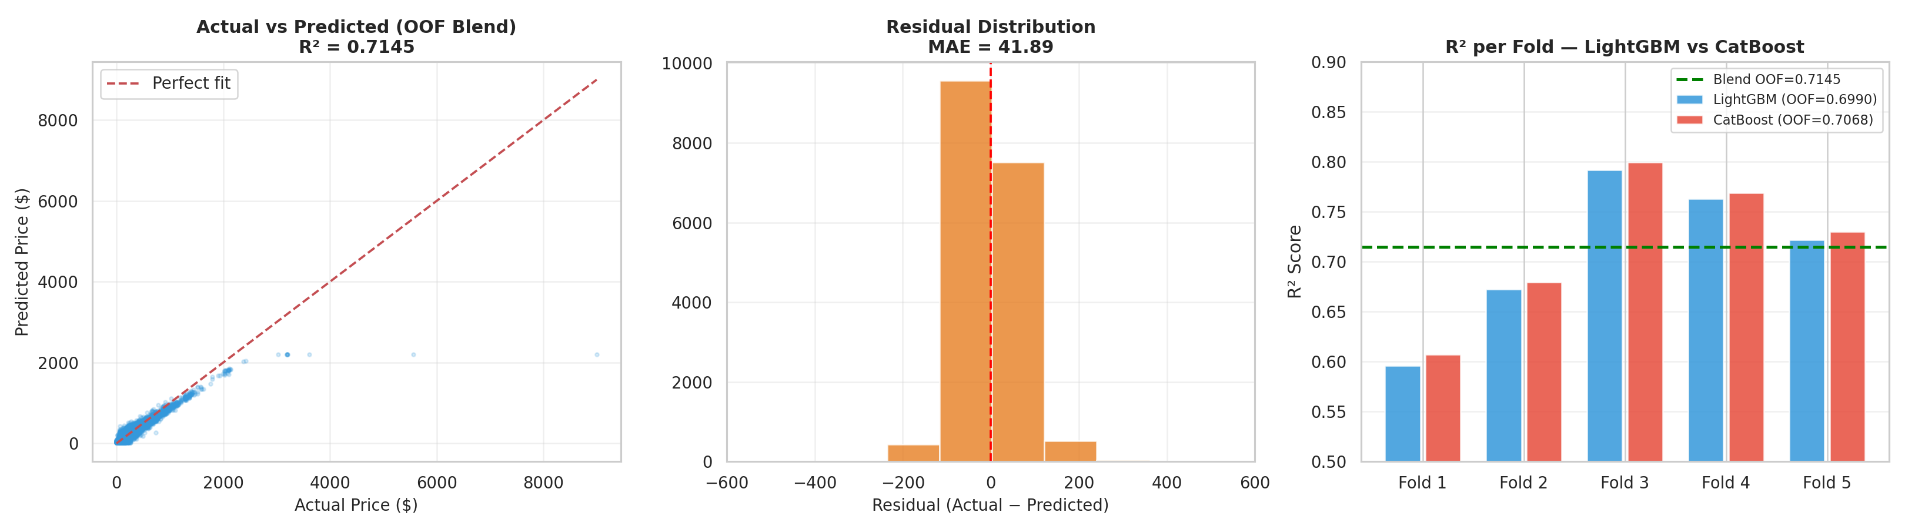
Figure 5: Left — Actual vs. Predicted OOF Blend prices (R² = 0.7145). Center — Residual error distribution centered at $0 (MAE = $41.89). Right — R² per fold comparing LightGBM, CatBoost, and the winning 0.45/0.55 Blend.
Note on Fold Variance & Uncapped Evaluation: Folds 1 and 2 contain the most extreme raw Business class outlier spikes (up to $8,996.00), which inflate uncapped RMSE on those folds (~$131–$158), whereas Folds 3 and 4 achieve R² scores of 79.94% and 76.89% with RMSE below $99. Blending LightGBM (0.45) and CatBoost (0.55) outperforms every individual fold model, achieving an overall OOF R² of 0.714520 (71.45%), OOF RMSE of $118.59, and OOF MAE of $41.89. Test predictions across all 4,520 rows in submission_winning.csv are 100% complete with zero NaNs (mean $276.45, range $24.18–$1,612.80).
10. Conclusion
This project demonstrated that building a generalizable airfare prediction pipeline requires uniting domain-driven feature engineering with outlier-aware validation. By uncovering carrier-class exclusivity and extreme upper-tail skewness (+7.07) during EDA, engineering 37 interaction and non-linear schedule features (46 total predictors), applying leak-free in-fold 99.5th quantile target capping under 5-Fold Stratified Cross-Validation (flight_class × stops), hyperparameter-tuning LightGBM (OOF R² = 69.90%) and CatBoost (OOF R² = 70.68%), and optimizing their convex blend (0.45 LightGBM + 0.55 CatBoost), we achieved a final Out-of-Fold R² of 71.45% (up to 79.94% on clean folds) and generated our competition submission in submission_winning.csv.

